There are three green candies in storage 4: a flat top candy, a flat top candy with a hole and a globe-shaped candy. A robot should move them to the 2nd storage in the same order and go back to the zero position. The task is deemed complete if each object touches only the respective stand of the 2nd storage and the robot stays at the zero position with the accuracy of at least 1.5 mm. Losing or lifting the candies again is not allowed during the task. The task should be complete within 120 sec.

Initial scene:

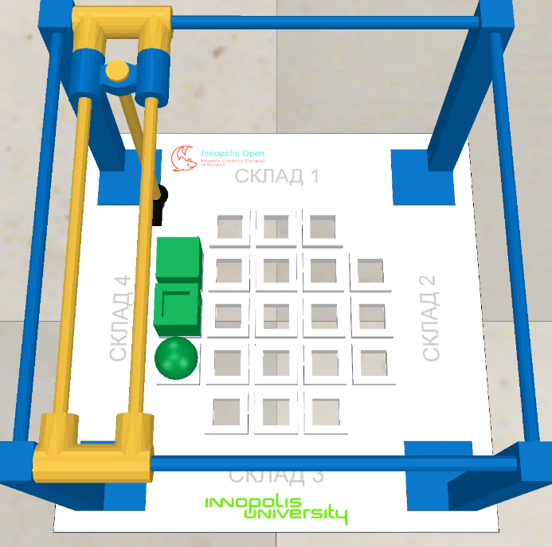

Complete task:

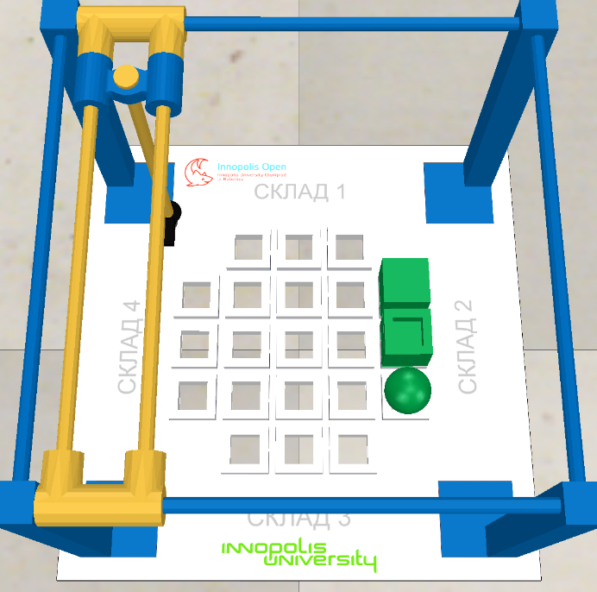

Three files with source code are accepted for answers:

- Child.lua – the source code of the program working in the asynchronous mode;

- Customization.lua - the source code of the program, working in the synchronous (step-by-step with the simulator) mode;

- ManIRS_junior.py – the source code of the robot control program in Python.

The program can be written in one of these files or in several files. The original versions of these files are located in the Programming/Lua and Programming/Python catalogues.